# Assignment #1 – Single Table Selects

1. **Which destination in the flights database is the furthest distance away, based on information in the flights table? Show the SQL query(s) that support your conclusion.**

Approach 1: select dest, max(distance) as distance from flights group by 1 order by 2 desc limit 1;

Approach 2 : select distinct dest, distance from flights where distance = (select max(distance) from flights)

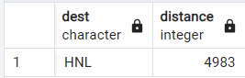

1. **What are the different numbers of engines in the planes table? For each number of engines, which aircraft have the most number of seats? Show the SQL statement(s) that support your result.**

select distinct model, engines, seats from (

select model, engines,seats, RANK() over (partition by engines order by seats desc) rank_no from planes) t

where rank_no = 1

order by 2

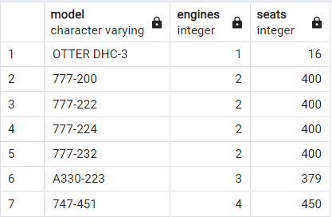

1. **Show the total number of flights.**

select count(*) as number_of_flights from flights

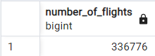

1. **One of the musicians does not like the smell of fish, so list all details of guests who are slotted to sit by the band and ordering Salmon (Meal Code of ‘S’). Return ordered by last name. Hint – consider ‘In’**

select g.* from guest g

join "Table" t on g."Table Number" = t."Number"

where g."Meal Code" in ('S')

and t."Near Band Ind" = true

order by "Last Name";

1. **How many guests have responded they are going to the Rehearsal Dinner (values of ‘A’ or ‘B’ only) who either have not responded or responded before May**

select count(*) as guest_count from guest

where "Rehearsal Participant Code" in ('A', 'B') and ("Response Date" is NULL

or extract(month from "Response Date") < 5)

